Peano curves
In mathematical analysis, a space-filling curve[1] is a curve whose range contains the entire 2-dimensional unit square (or more generally an N-dimensional hypercube). Because Giuseppe Peano (1858–1932) was the first to discover one, space-filling curves in the 2-dimensional plane are commonly called Peano curves.
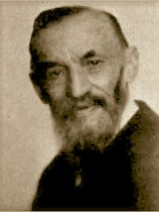
Implementation
Workbook: Fractal/Finished Works/Worksheets/L system/Peano Curves/Unexpanded/Original Peano Curve
Peano curves follow the same implementation as other Lsystem fractals. There are a whole lot set of Peano curves available and even Hilbert, Fass curves are a variation of Peano curves. We have also seen Gosper Peano curves in the previous chapter. The initial parameters are given in the figure below.
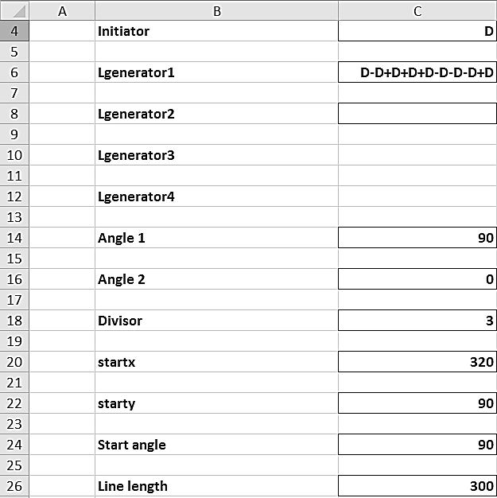
Move onto Level 1 in the workbook and expand the data points as before and plot the chart. Level 1, 2 and 4 are shown below.
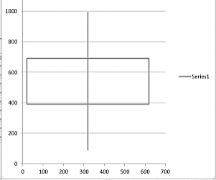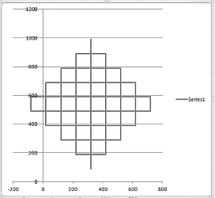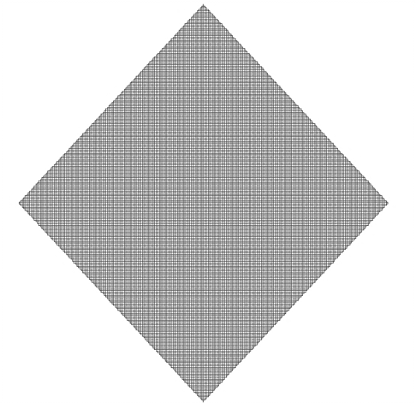
Level 4 curve looks like a mat. You can now visualize a level 7 or 8 curve which hardly can be seen through. This is why it is called a space filling curve and since it is a curve of 1 dimension filling a space of 2 dimension, it is called fractional dimension.
Modified Cesaro Triangle
Cesaro triangle is another Peano curve which fill a triangle. It is a straight forward implementation, which would be a repetition. So we are including the implementation of Modified Cesaro triangle only. The modified Cesaro triangle includes the usage of Angle2. If you could remember the way we used Angle 2 for Gosper curves, where in we added the Angle 2 with Start angle and made it to 0, the notable difference here is that we are going for the real usage of Angle2. Even if we have been using ‘*’ and ‘#’ before, its effect was 0. Here though we are going to use Angle2 for ‘*’ and ‘#’
Implememtation
Workbook: Fractal/Finished Works/Worksheets/L system/Gosper Curves/Unexpanded/Modified Cesaro Triangle.
Have a look ate the firure elow for the initial parametesr. Rest of the implementation is the same as described in Gosper Island. Level 1, 2 and 7 are shown in figures below. Only natable part is that, from the filter window, select only D and Blanks fro plotting.
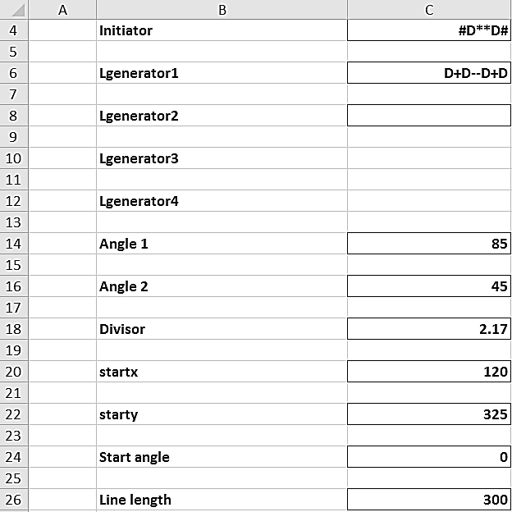
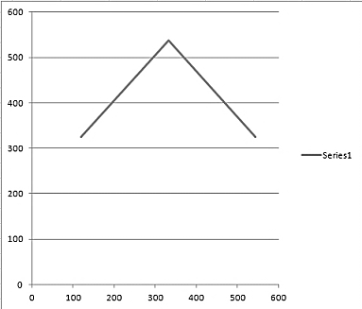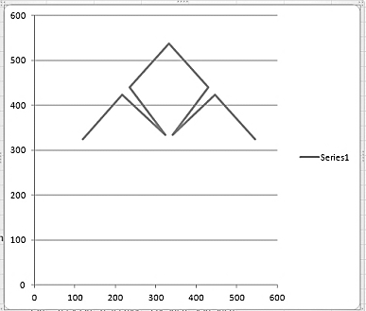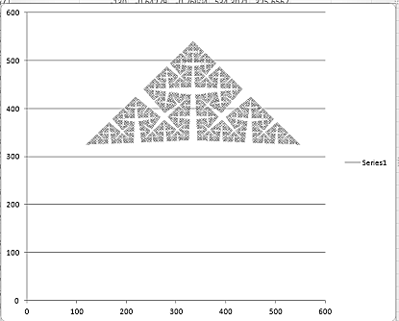

Harter Heighway Dragon Curve
The Heighway dragon [2] (also known as the Harter–Heighway dragon or the Jurassic Park dragon) was first investigated by NASA physicists John Heighway, Bruce Banks, and William Harter. It was described by Martin Gardner in his Scientific American column Mathematical Games in 1967. Many of its properties were first published by Chandler Davis and Donald Knuth. It appeared on the section title pages of the Michael Crichton novel Jurassic Park.
The construction of A Dragon curve goes in steps like in the figure given below
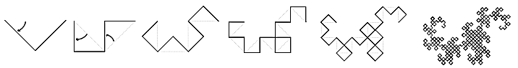
Implementation
Workbook: Fractal/Finished Works/Worksheets/L system/Peano Curves/Expanded/Harter Heighway Dragon Curve
The Dragon curve uses L and R pattern strings for Fractal generation it is similar to Peano Cosper curve in the previous chapter.
The initial Parameters are shown in the figure
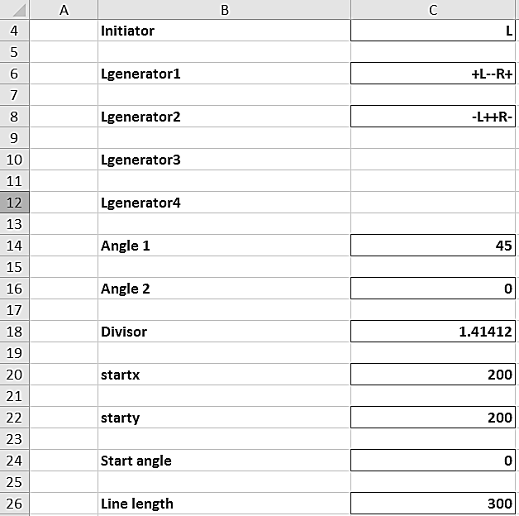
Level 1, 2, 3 and 13 are shown in figures below.
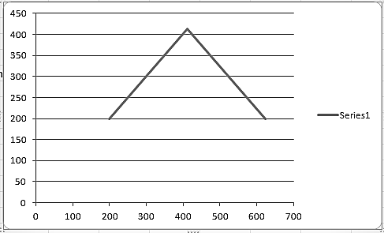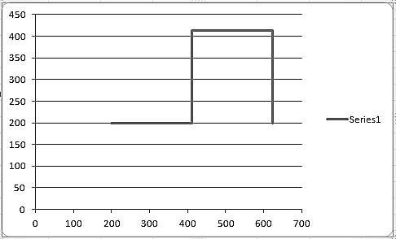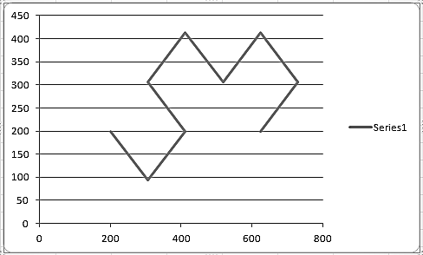
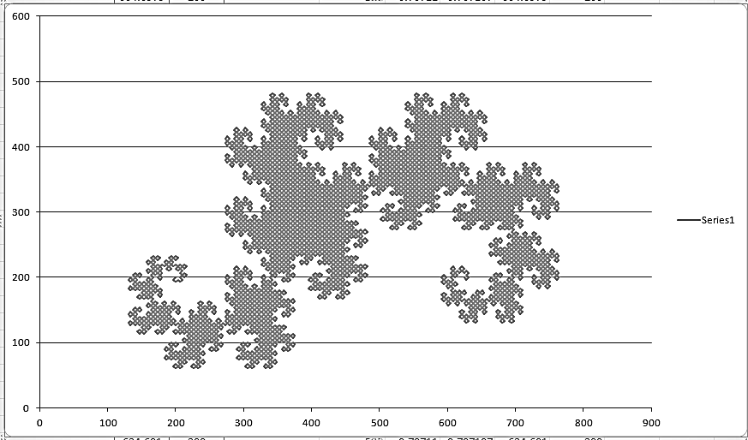

Hilbert curve
A Hilbert curve (also known as a Hilbert space-filling curve) is a continuous fractal space-filling curve first described by the German mathematician David Hilbert in 1891,[3] as a variant of the space-filling curves discovered by Giuseppe Peano in 1890.
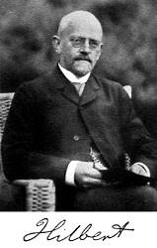
It has a difference as compared to other Lsystem curves. Whatever we have been seeing until now was Edge replacement Fractals. Every edge in the previous level was replaced by a string. In Hilbert curve, the two generators, r and l are inserted at designated junctions between lines for levels above 0. This is called node replacement.
Implementation
Woprkbook: Fractal/Finished Works/Worksheets/L system/Hilbert Curves/Expanded/Hilbert Curve 1
The implementation of Hilbert has a difference compared to other curves. For this take a note of the below given figure of initial parameters. Note the usage of ‘r’ and ‘l’. They are small letters in place of ‘R’ and ‘L’ we have used before. The speciallity is that after generating the final level string, r and l are not used for drawing. The generator string contains only D as drawing symbols. However for replacement, r and l are used. Look at the figure for details
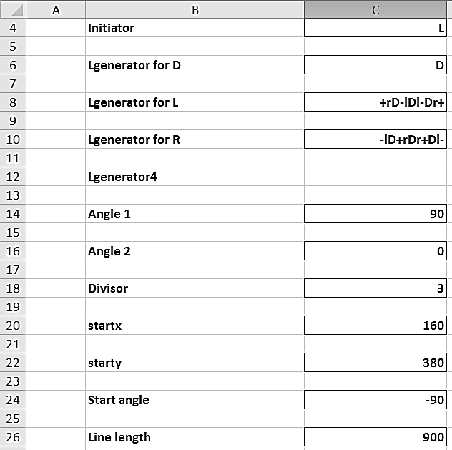
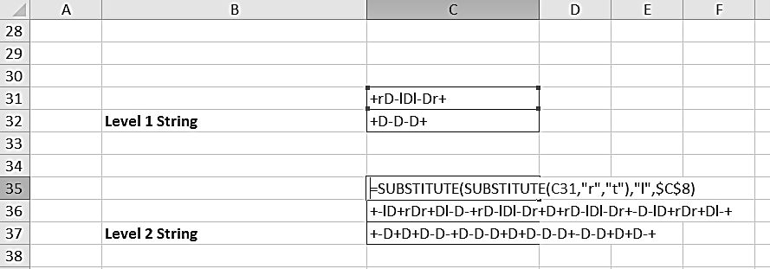
Reset of the implementation is the same as Original Peano curve, because the string contains only D, + and -. Levels 1, 2, 7 looks like the figures below.
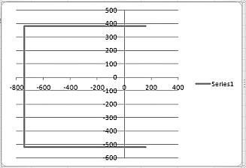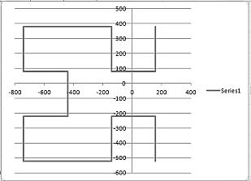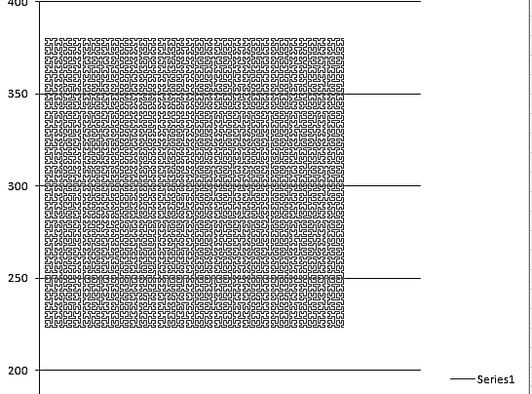

Hilbert Curve 2
Workbook: Fractal/Finished Works/Worksheets/L system/Hilbert Curves/Expanded/Hilbert Curve 2
Initial paremeters are given in the below figure
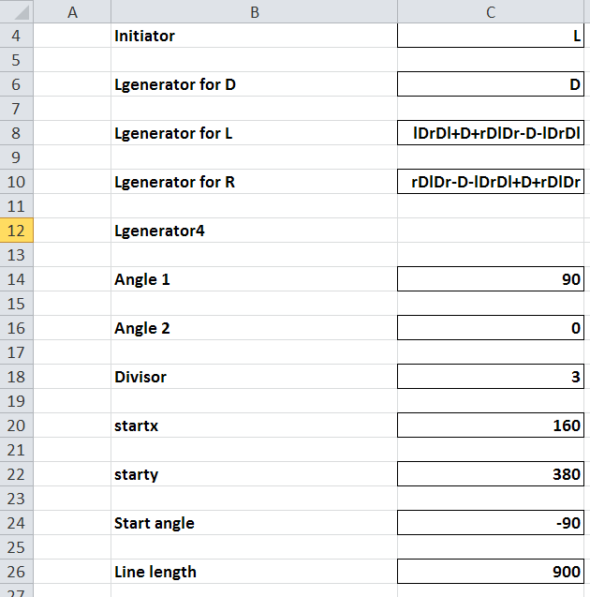
Level 1, 2, 4 curves are shown below
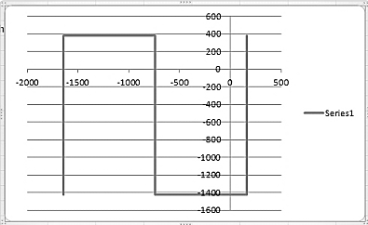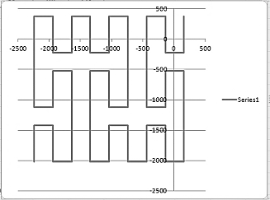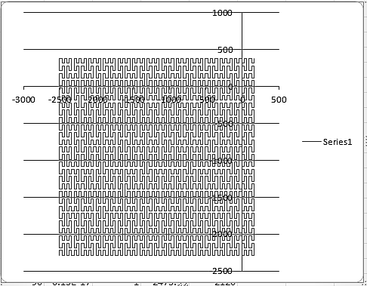
Fass Curves
Fass Curves are space filling, self-avoiding, simple and self-similar. They are similar to Von Koch except that the initiator is always a straight line and the angle is always limited to 90 degrees. The number of orientations are limited and this enables us to have more lines into the generator, which finally results in the curve filling the entire space eventually on higher levels.
Implementation
All the Fass curve we are including are following the previous fractals using L, R, D, l and r. So to avoid repetition, we are including only the Initial parameters and the Graphs. However we would recommend the reader to generate each pattern from the unexpanded files of ours to get the feel of how the Fass curves look like and understand their difference with other space filling curves.
Fass curve 1
Workbook: Fractal/Finished Works/Worksheets/L system/Hilbert Curves/Expanded/Fass Curve 1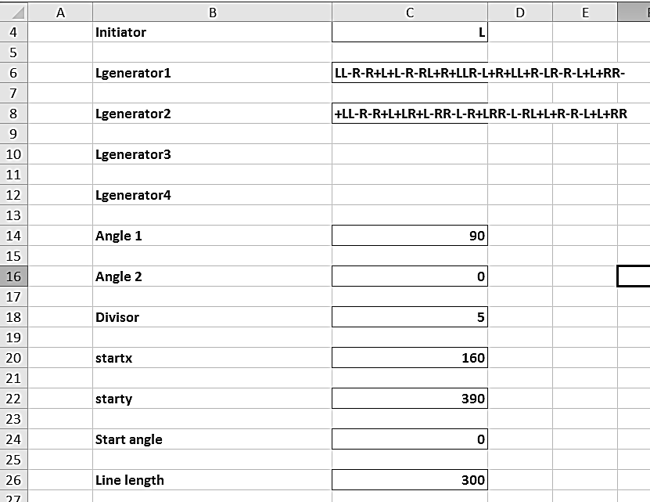
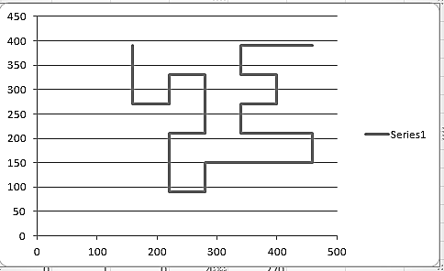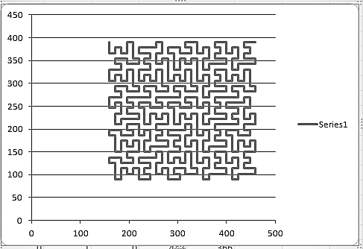
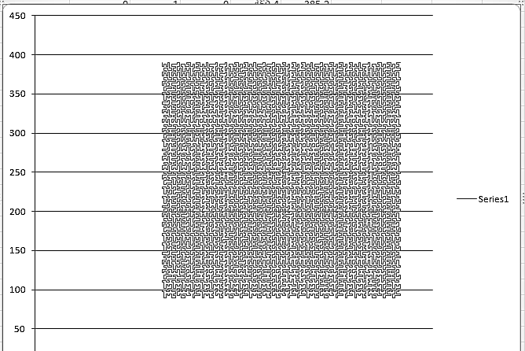
Fass Curve 4
Workbook: Fractal/Finished Works/Worksheets/L system/Hilbert Curves/Expanded/Fass Curve 4

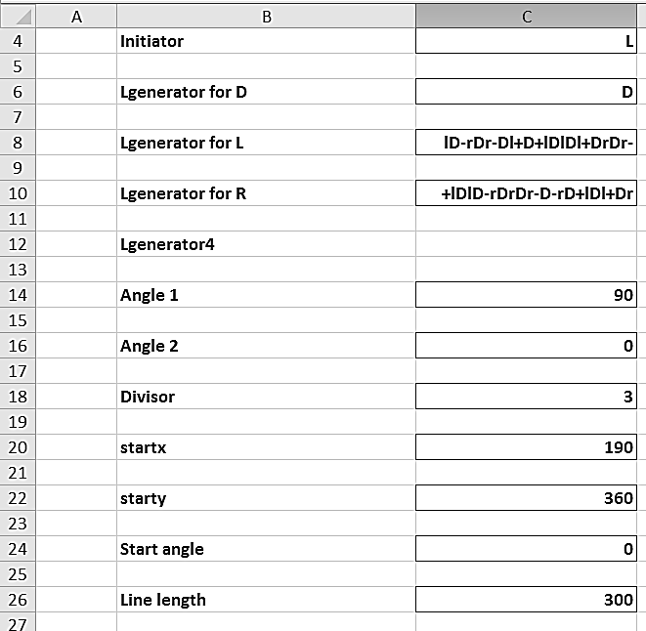

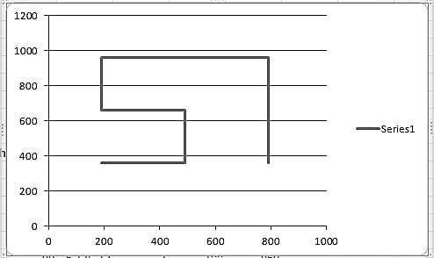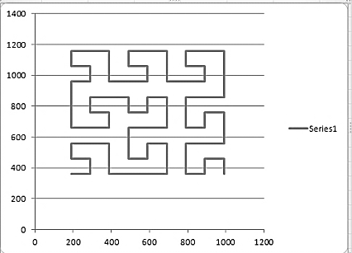
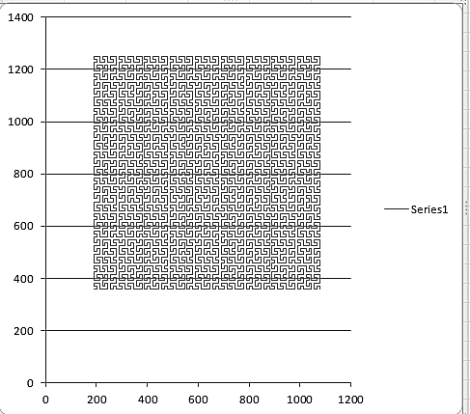

Fass Curve 5
Workbook: Fractal/Finished Works/Worksheets/L system/Hilbert Curves/Expanded/Fass Curve 5

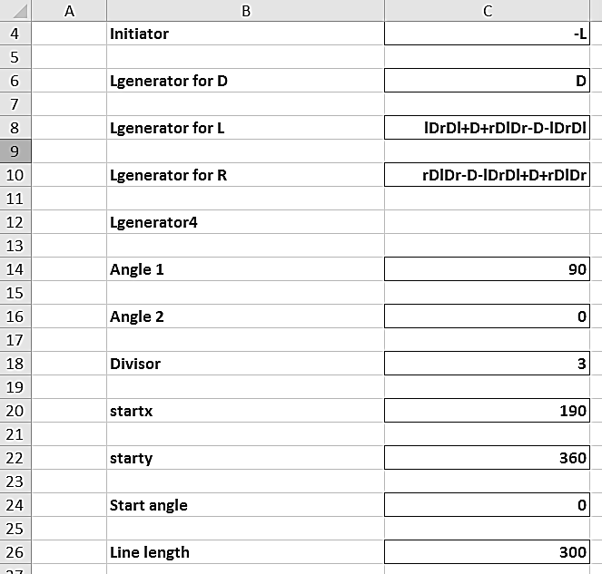
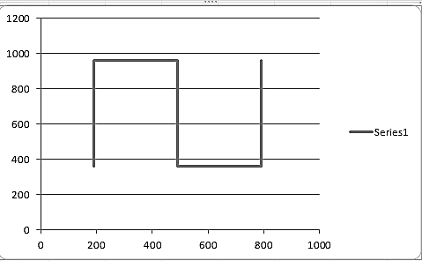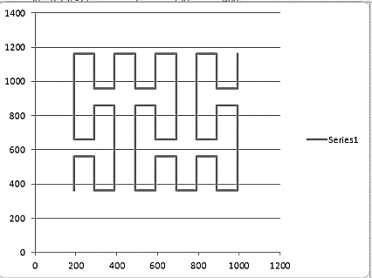
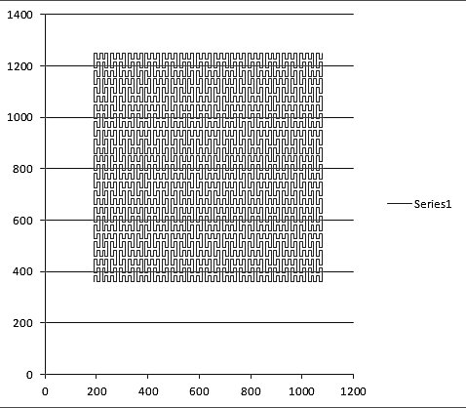

Fass Curve 6
Workbook: Fractal/Finished Works/Worksheets/L system/Hilbert Curves/Expanded/Fass Curve 6
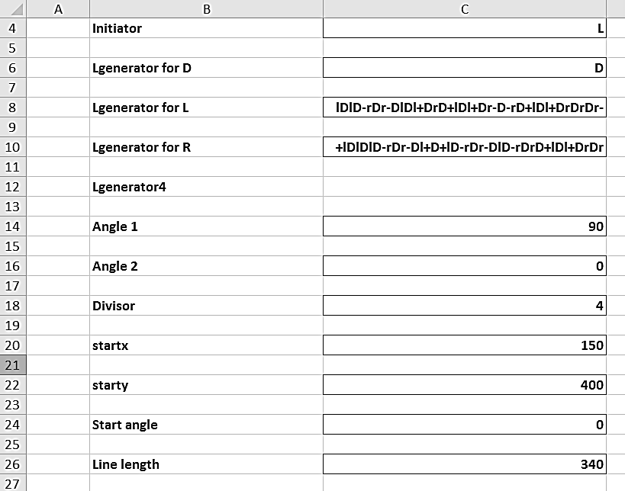
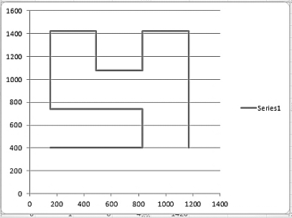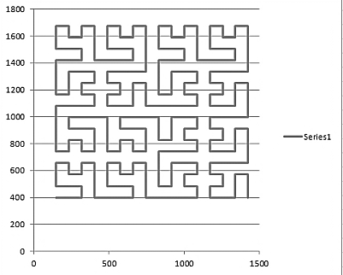
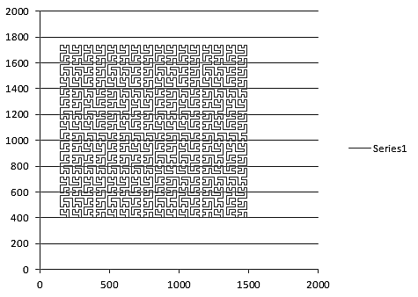
Fass Curve 7
Workbook: Fractal/Finished Works/Worksheets/L system/Hilbert Curves/Expanded/Fass Curve 7
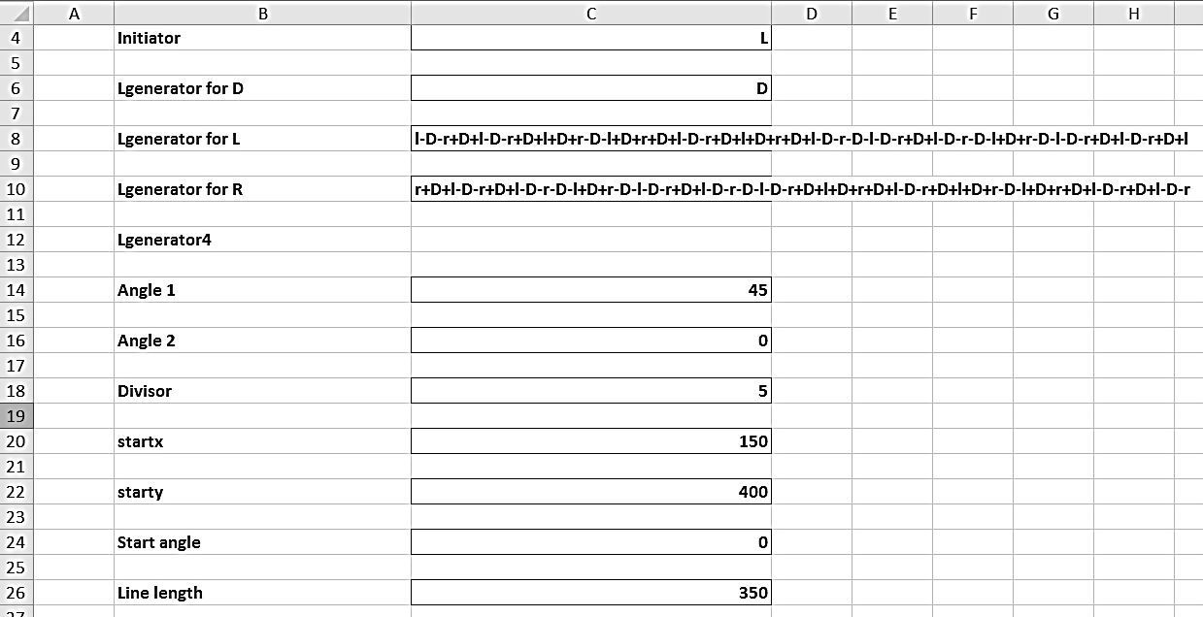
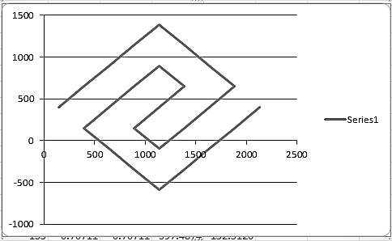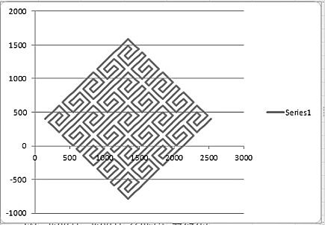

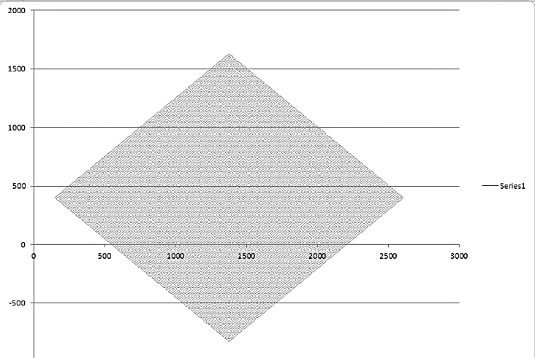
Reference
http://en.wikipedia.org/wiki/Space-filling_curve
http://en.wikipedia.org/wiki/Dragon_curve
http://en.wikipedia.org/wiki/Hilbert_curve

